**CURRICULUM VITAE**

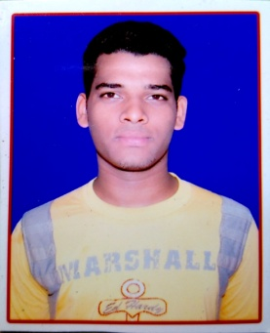

**MAHENDRA BISWAL**

Phone No. :- (+91)9556556064, (+91)9938207511

Email Id :-[mahendradstar@gmail.com](mailto:mahendradstar@gmail.com)

|  |
| --- |
| **OBJECTIVE** |

To work in a globally competitive and creative environment that challenges existing norms and encourages innovative ideas.

|  |
| --- |
| **TECHNICAL SKILLS/PROJECT UNDERTAKEN** |

* Actively involved in Event Management of college function and miscellaneous activities.
* Summer Internship at **PEPSICO**
* member of committee for legal aid to poor
* voluntary in NSS

|  |
| --- |
| **ACADEMIC QUALIFICATION** |

|  |  |  |  |  |  |
| --- | --- | --- | --- | --- | --- |
| **NAMEOF EXAM** | **BOARD/**  **UNIVERSITY** | **NAME OF THE**  **INSTITUTION** | **STREAM** | **YEAR OF**  **PASSING** | **PERCENTAGE**  **(%)** |
| M.B.A. | B.P.U.T | Institute of Management and Information Technology |  | 2017 | Pursuing |
| Graduation | Utkal University | R R V D M V,college | PCM PASS | 2015 | 60.33 |
| Intermediate | C.H.S.E | G.Sc college,athgarh | SCIENCE | 2012 | 51.33 |
| Matriculation | H.S.C | MSS bidyapitha,joranda | ALL SUBJECTS | 2010 | 70.33 |

|  |
| --- |
| **OTHER SKILLS** |

* APGDCA with in-depth knowledge of MS-Office package,
* Adobe Pagemaker, Photoshop
* Pinnacle studio 15

|  |
| --- |
| **STRENGTHS** |

* Ability to motivate people, work in a team and perfecting new skills.
* Intense work capable of acute concentration for long hours.
* Have good communication and interpersonal skills.
* Team player with a strong work ethics, punctual and committed to hard work.
* I am a quick learner.

|  |
| --- |
| **HOBBIES AND INTERESTS** |

* Exploring new horizons of nature.
* Interested in listening to DJ music and advertises
* Video editing and audio mixing
* Physical stunts and dancing

|  |
| --- |
| **PERSONAL DETAILS** |

**Father’s Name** Mr.Arabinda Biswal**:**

**Mother’s Name :** Mrs. Susama Biswal

**Date of Birth :** 11th july 1995

**Permanent Address :**AT/po-karikol,p.s-athgarh, Dist- Cuttack

Odisha, PIN-754029

**Gender**  **:** Male

**Marital Status** **:** Single

**Nationality**  **:** Indian

**Religion:** Hindu

**Languages Known :** English, Hindi and Odia.

**Passport no. :** A/F

**Aadhar No.:**865704556181

|  |
| --- |
| **DECLARATION** |

I do hereby declare that the above furnished details are true to the best of my knowledge and belief.

Date:

Place: Signature